Typical Database Management System Architecture [Diagram]
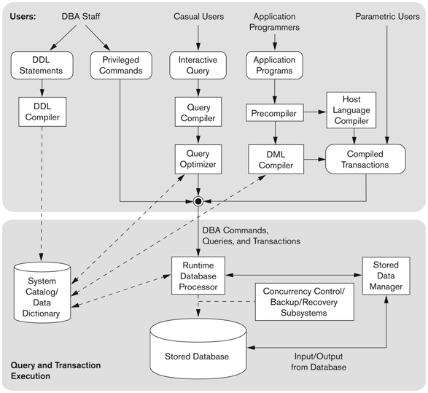

Typical Database Management System Architecture [Diagram Explanation]
This is a Typical Database Management System (DBMS) Architecture, showing how different types of users interact with a database.
Main Sections of the Diagram
The diagram consists of two major sections:
- Users and Their Interactions with the DBMS
- Query and Transaction Execution

1. Users and Their Interactions with the DBMS
Different types of users interact with the database system in different ways:
a) DBA Staff (Database Administrators)
- DDL Statements: The DBA (Database Administrator) defines the database schema using Data Definition Language (DDL). These statements specify:
  - Table structures
  - Indexes
  - Constraints, etc.
- DDL Compiler: It processes the DDL statements and updates the System Catalog/Data Dictionary, which stores metadata about the database.
- Privileged Commands: DBA staff can also execute special commands for managing security, user access, and performance tuning.
b) Casual Users
- These users interact with the database through interactive queries.
- The process:
  - Query Compiler: Parses and converts user queries into an internal form.
  - Query Optimizer: Optimizes the query for efficient execution.
c) Application Programmers
- Application Programs: Developers write applications that interact with the database.
- Precompiler: Converts embedded queries in a high-level programming language (e.g., C++, Java) into database commands.
- DML Compiler: Processes Data Manipulation Language (DML) statements (like SELECT, INSERT, UPDATE, DELETE).
- Host Language Compiler: Compiles the application along with the processed database queries.
- Compiled Transactions: The final compiled code executes database transactions.
d) Parametric Users
- These users run predefined, frequently used transactions (e.g., in banking or airline reservation systems).
- Stored Data Manager: Manages and executes these compiled transactions efficiently.

2. Query and Transaction Execution
Once the user inputs queries or transactions, the DBMS processes them as follows:
- Query Compilation and Optimization
  - The Query Compiler translates queries into an intermediate form.
  - The Query Optimizer improves efficiency by choosing the best execution plan.
- Runtime Database Processing
  - The Runtime Database Processor is responsible for actually executing queries and transactions.
- System Catalog/Data Dictionary
  - Stores metadata like table structures, indexes, constraints, and user permissions.
  - The DBMS references this information during query execution.
- Concurrency Control, Backup, and Recovery
  - Ensures data integrity when multiple users access the database simultaneously.
  - Handles database recovery in case of system failures.
- Stored Database and Stored Data Manager
  - The actual Stored Database contains the user data.
  - The Stored Data Manager is responsible for retrieving and storing data efficiently.

Summary of the Flow
- Users interact with the database through different interfaces.
- The queries go through compilation, optimization, and execution.
- The Runtime Database Processor processes queries and transactions.
- Data retrieval and storage are managed by the Stored Data Manager.
- Concurrency control and backup mechanisms ensure data integrity.

Final Thoughts
This architecture ensures that databases are efficient, secure, and reliable for all types of users.

